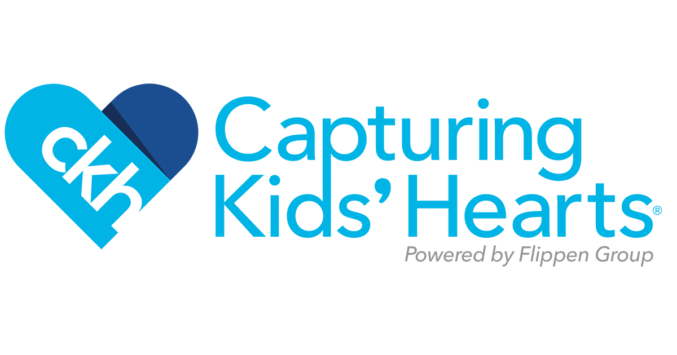

When CKH-1 is combined with a systemic approach, our research-based process improves the five key indicators of school performance: fewer discipline referrals, improved attendance, higher student achievement, lower dropout rates, and higher teacher satisfaction.

Campuses implementing with fidelity have experienced:

* Strengthened student connectedness to others by enhancing healthy bonds with teachers
* Consistent rules of conduct, with reduced disciplinary escalations and referrals
* Dramatic reduction in truancy and dropouts
* Reduced negative behaviors
* Significant improvement in student academic performance
* District-wide improvements in test scores
* Higher rate of job satisfaction among teachers
* Increased teacher retention and improvement in teacher recruiting

 